NNAMDI AZIKIWE UNIVERSITY

FACULTY OF ENGINEERING

ELECTRONICS AND COMPUTER ENGINEERING

FEG 201 APPLIED ELECTRICITY

TOPIC: COMMON BASE CONFIGURATION OF BC1O7 NPN TRANSISTOR

LECTURER: ENGR. CYPRIAN

Group 12

S/N NAMES REG. NO.

1. CHUKWUMA DANIEL CHIMEREMEZE 2022364122
2. NDIBE EBUBECHUKWU LUCY 2022364123
3. CHUKWU CHIBUIKEM DOMINIC 2022364124
4. NWOSU CHIBUIKEM HENRY 2022364125
5. NDUBUISI CHIBUZO VICTOR 2022364126
6. OGUGUA PAUL EBUKA 2022364127
7. IWUCHUKWU DANIEL CHINAZA 2022364128
8. AZUKA CHRISTIAN ODINAKACHUKWU 2022364129
9. RAPHEAL TOCHUKWU WINNER-PRAISE 2022364130
10. OKEKE CHIDUBEM NSOBUNDU 2022364131
11. ONWURAH KINGSLEY UCHENNA 2022364132

OBJECTIVES OF THE EXPERIMENT

* To plot the input and output characteristics of a transistor and to compute the H-parameters.

Apparatus:

|  |  |  |  |  |  |
| --- | --- | --- | --- | --- | --- |
| Apparatus | Type | | Range | | Quantity |
| Transistor | BC107 | | _____ | | 1 |
| Resistor | _____ | | 1kΩ | | 2 |
| Regulated power supply | _____ | | 0 – 30V | | 2 |
| Ammeter | _____ | | 0 – 100mA | | 2 |
| Voltmeter | _____ | (0-2V)  (0-20V) | | | 1 |
| Bread board | _____ | _____ | | 1 | |
| Wire | _____ | _____ | | 1 | |

Circuit Diagram:

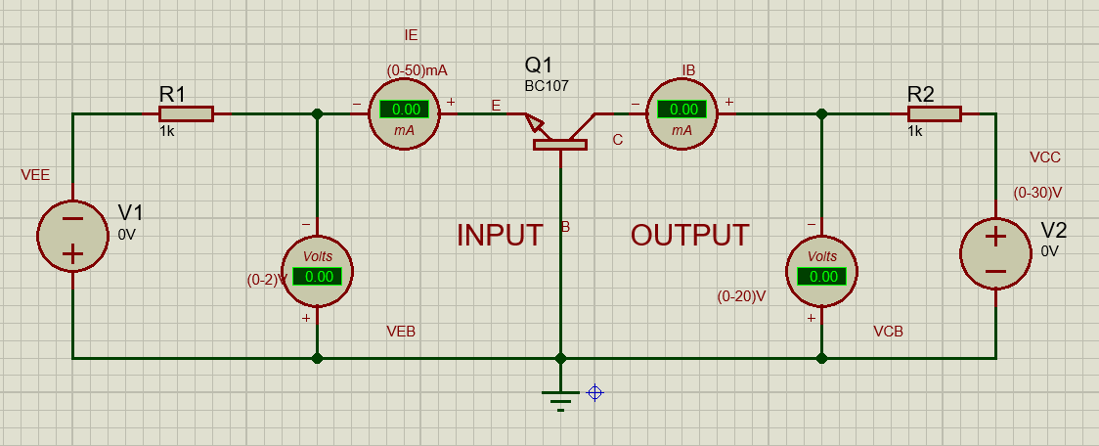

Procedures:

Input Characteristics:

* Connect the transistor in common base configuration as per the circuit diagram.
* Keep the output Voltage VCB = 0V by varying VCC
* By varying VEE, vary VEB in steps of 0.1 V and note down the emitter current, IE, reading
* Repeat the above procedure (step 3) for various values of VCB (VCB = 5V and VCB = 10V)
* Tabulate your result from above variation
* Plot the input characteristics model graph.

Table of Values for Input Characteristics:

|  |  |  |  |  |  |  |  |  |
| --- | --- | --- | --- | --- | --- | --- | --- | --- |
| INPUT CHARACTERISTICS | | | | | | | | |
| VCB | | | VCB | | | VCB | | |
| 0V | | | 5V | | | 10V | | |
| VEE (V) | VEB (V) | IE (mA) | VEE (V) | VEB (V) | IE (mA) | VEE (V) | VEB (V) | IE (mA) |
| 0 | 0 | 0 | 0 | 0 | 0 | 0 | 0 | 0 |
| 0.1 | 0.1 | 0 | 0.1 | 0.1 | 0 | 0.1 | 0.1 | 0 |
| 0.2 | 0.2 | 0 | 0.2 | 0.2 | 0 | 0.2 | 0.2 | 0 |
| 0.3 | 0.3 | 0 | 0.3 | 0.3 | 0 | 0.3 | 0.3 | 0 |
| 0.4 | 0.4 | 0 | 0.4 | 0.4 | 0 | 0.4 | 0.4 | 0 |
| 0.5 | 0.5 | 0 | 0.5 | 0.5 | 0 | 0.5 | 0.5 | 0 |
| 0.65 | 0.6 | 0.05 | 0.65 | 0.6 | 0.05 | 0.66 | 0.6 | 0.06 |
| 1.6 | 0.7 | 0.9 | 3 | 0.7 | 2.3 | 3.21 | 0.7 | 2.51 |
| 2.6 | 0.8 | 1.8 | 7.18 | 0.8 | 6.38 | 11.86 | 0.8 | 11.1 |
|  |  |  |  |  |  |  |  |  |

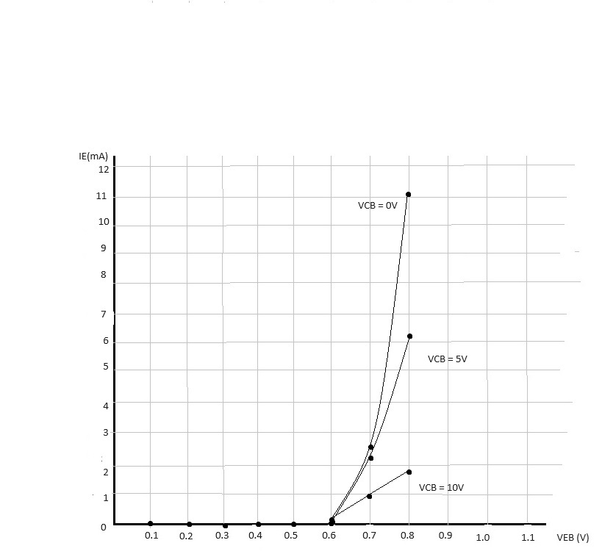

Fig 1: Input Characteristics Graph

CALCULATIONS:

1. Input Impedance

SLOPE= IE/VEB = (11.1-2.51) x 10^-3 / 0.87-0.7

= 0.0859

Input Impedance = 1/slope = 11.6 ohms

Output Characteristics:

* Make the connections as shown in the circuit diagram above
* By varying VEE, keep the base current, IB = 10mA
* By varying VCC, vary VCB in steps of 1V and note the readings of the collector current IC
* Repeat above procedures in step 3 for different values of IE (IE = 15mA and IE =20mA)
* Tabulate your readings from above variations
* Plot the output characteristics model graph

Table of Values for Output Characteristics:

|  |  |  |  |  |  |  |  |  |
| --- | --- | --- | --- | --- | --- | --- | --- | --- |
| IE | | | IE | | | IE | | |
| 10mA | | | 15mA | | | 20mA | | |
| VCC (V) | VCB (V) | IC (mA) | VCC (V) | VCB (V) | IC (mA) | VCC (V) | VCB (V) | IC (mA) |
| 0 | -1.41 | 1.41 | 0 | -1.77 | 1.77 | 0 | -2.14 | 2.14 |
| 9.86 | -0.41 | 10.3 | 10.4 | -0.77 | 11.2 | 10.39 | -1.14 | 11.5 |
| 11.3 | 0.59 | 10.7 | 16.19 | 0.23 | 16 | 20.39 | -0.14 | 20.5 |
| 12.3 | 1.59 | 10.7 | 17.19 | 1.23 | 16 | 22.17 | 0.86 | 21.3 |
| 13.3 | 2.59 | 10.7 | 18.19 | 2.23 | 16 | 23.17 | 1.86 | 21.3 |
| 14.3 | 3.59 | 10.7 | 19.19 | 3.23 | 16 | 24.18 | 2.86 | 21.3 |
| 15.3 | 4.59 | 10.7 | 20.2 | 4.23 | 16 | 25.18 | 3.86 | 21.3 |
| 16.3 | 5.59 | 10.7 | 21.2 | 5.23 | 16 | 26.18 | 4.86 | 21.3 |

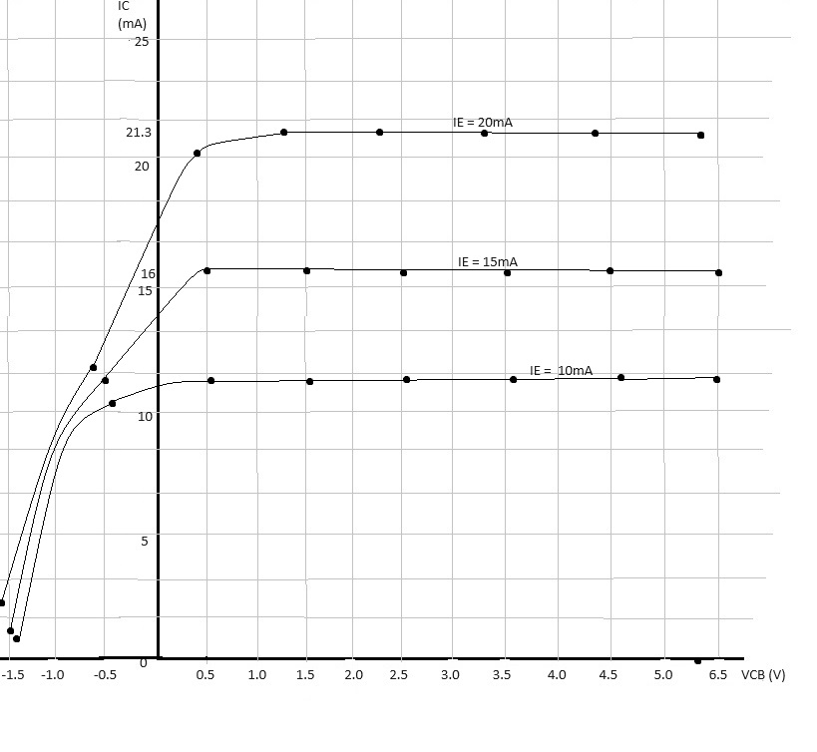

Fig 2: The Graph of Output Characteristics

CALCULATIONS:

1. Output Admittance (hob)

SLOPE = IC/VCB= (10.3 – 1.41)x 10^-3 /-0.41+1.41 = 0.00889 siemens

OUTPUT ADMITTANCE = SLOPE= 0.00889 siemens

Precautions:

* We took necessary precautions so as not to exceed the ratings of the transistor. This may lead to damage of the transistor.
* We made sure the voltmeter and ammeter are connected in correct polarities as shown in the circuit diagram.
* We cross-checked the circuit connections on the circuit diagram before switching on the voltage supply.
* We made sure we connected the transistor in the right manner following the circuit diagram.